Team Maultier- From the Ground Up Challenge entry
Two 15th Century Mounted Tourney trained and equipped Mules
By Her Ladyship Ise no Kusunoki Kametsuru and Sir Sato Jiro no Bitchu

We present for your review two 15th Century style Mounted Tourney trained Mules. Why are they from the ground up you might ask? We have been training these 2 mules for SCA art of mounted tourney games for 5 years and we have made all the training equipment that goes into training an equine to do the equestrian games. Such as barding, chamfrons, quintains, lance racks, reeds and head stands, Ring Stands, Lances and pennons, swords and scabbards, spears and more. All of these things are the components from the ground up to make a trained Tourney equine and we made them ourselves and combined them with our training hours with the mules to create 2 mules who have won many Tourney competitions over the last years and continue to improve and are trained from the ground up.

The Tourney
The words "tournament" and "joust" are often used interchangeably. Strictly speaking "joust" describes single combat between two horsemen. "Tournament" refers to mounted combat between parties of knights, but also is used to refer to the whole proceeding. Some History behind “The Tourney”-The tournament, properly so called, appear in Europe by the early 12th centrury. A chronicler of Tours in the late twelfth century records the death, in 1066, of an Angevin baron named Geoffroi de Preulli, who supposedly "devised" or "invented" (invenit) the tournament. Rüxner's 16th-century Thurnierbuch details the supposed tournament laws of Henry the Fowler (king of Germany, 919-936).
The earliest known use of the word 'tournament' comes from the peace legislation by Count Baldwin III of Hainaut for the town of Valenciennes, dated to 1114. It refers to the keepers of the peace in the town leaving it 'for the purpose of frequenting javelin sports, tournaments and such like.' Hermann of Tournai in the early 1140s, refers to the accidental death of Henry III, Count of Leuven in Tournai in 1095 in a meeting between his knights and those of the castellan of Tournai.

What is a mule?
A mule is the hybrid offspring of a male donkey and a female horse. By crossing the two breeds you get the best of both horses and donkeys. As aficionado’s of the mule we claim that they are "more patient, sure-footed, hardy and long-lived than horses, and they are considered less obstinate, faster, and more intelligent than donkeys.
Are Mules Period?
Mules throughout history are the mounts of Kings, Popes and important persons of wealth.
They are referred to over and over in the bible. Mules were traditionally reserved for the royal family (2 Samuel 13:29; 18:9). Mules were traditionally reserved for the royal family. Since Hebraic law forbade crossbreeding (Leviticus 19:19), mules had to be imported and were therefore very expensive. So while the common people rode donkeys, the mule was reserved for royalty.
Some period reference to mules include – Pope Urban VI - died 1389 from injuries sustained after falling from a mule.
And Paien de Maisières' Arthurian romance La Mule sans Frain, The Mule without a Bridle, dating to the early 13th century tells a story of a maiden who arrives at King Arthur's court asking for a knight to help her to reclaim her mule's bridle. Sir Kay accepts the challenge but soon returns in defeat. Sir Gawain sets off, traverses a forest full of wild animals that all bow to the mule,
Pictures of Mules in Period
Below is the “Journey of the three Magi” by Benozzo Gozzoli 15th century. The leader of the procession in blue is clearly riding a mule with scalloped strap barding and matching reins. (Reference = Medieval Pageant by Bryan Holme ISBN-0-500-01421-3)
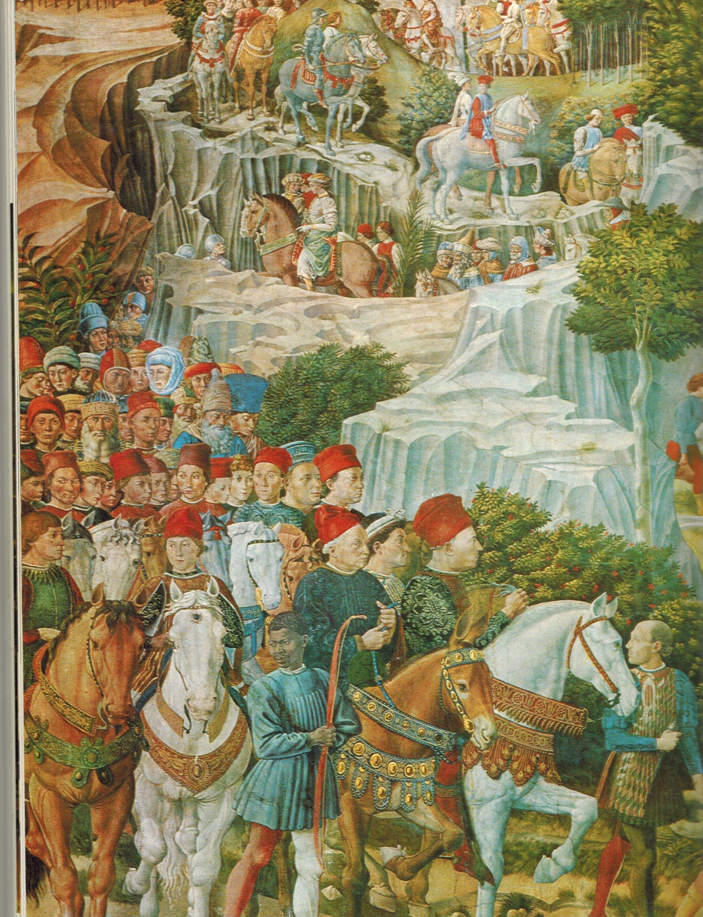

Seen below - Strap Barding. Reins and 2 Chamfrons- Leather tooled and hot branded then dyed and painted using modern leather dye(purple) and painted on Acrylics. This style of barding can be seen above and in many period depictions.
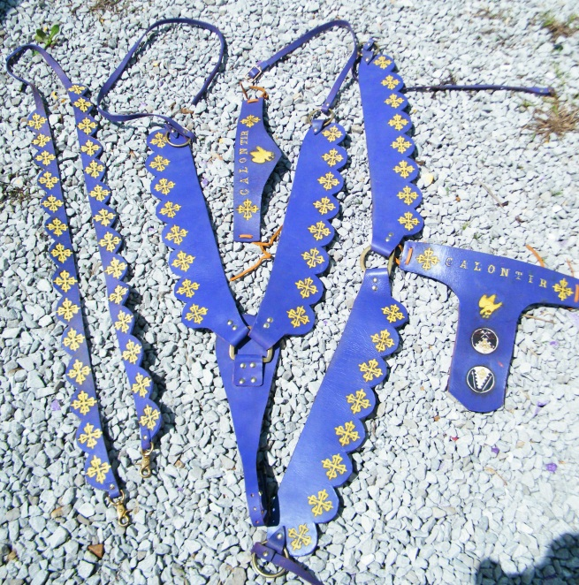
Seen Below - Quintain and Ring stands
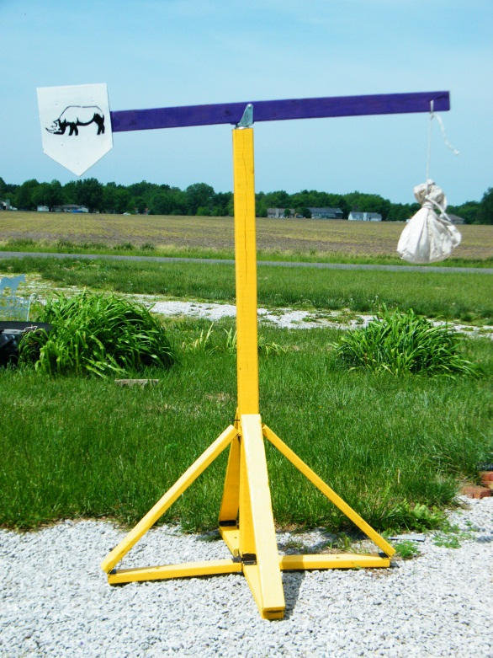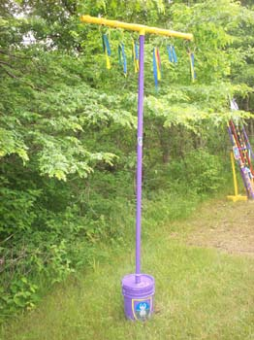
Description of Quintain-The training method used during the Middle Ages to teach a horse and rider to use a lance was the Quintain. A quintain was used to help to train a knight and his mount in the effective use of the lance and charging techniques. It consisted of a shield and dummy which was suspended from a swinging pole. When the shield was hit by a charging squire, a knight in training, the whole apparatus would rotate. The squire's task was to avoid the rotating arms and not get knocked from the saddle
- The rotating arms sometimes had a heavy sandbag attached to them
Accuracy was also an important factor and squires practiced "Running at the Rings" where the lance was aimed at a target in the shape of a ring - these rings were obviously much smaller to lance than a man and this skill was therefore difficult to master.
Quintain Training
Skill in using Medieval weapons was dependent on weapon practice. The Quintain was used for training in the use of the Medieval Lance. A quintain enabled target practice with a lance. This idea was 'borrowed' from the Romans.
The First Stage of training - A Page would start to acquire the skills required of a Knight by practising the skills of tilting a lance against the quintain. At first a target was erected and the Page would mount a wooden 'horse' on wheels holding a lance. The wooden horse would be pulled along by two other pages towards the target and the page would aim the lance.
The second stage of training - As the apprentice Knights, the squires, acquired the skills of horsemanship they would practice against a shield and dummy which were suspended from a swinging pole. The shield was hit by a charging squire and his objective was to avoid the rotating arms and not get knocked from the saddle. The dummy was often made to look realistic by portraying symbols of the knights current enemy. A dummy would be designed to look like a Saracen, for example, during the period of the crusades.
Weapons practice - Fully fledged knights would also practice at the quintain to ensure their skills using the lance were in peak condition and that their bodies remained fit and agile in preparation for his role as a fighter.

Reference= Jousts and Tournaments Elizabethan Sports by Gretchen Elaine Maxwell and Alan Ryan Carey
How our Quintain and Ring Stands were made - The above pictured Quintain is based on period photos and descriptions and is heavy pine and has a heavy 4 leg base to be able to take the lance hits and stayt upright yet be portable. And was assembled using hinges so it can be broken down to take to events and practices by just removing the pins. The Ring stand is similar to a period design bit ours is based out of PVC instead of wood. This was done to save weight for travel and to allow for it to break down for easy packing.
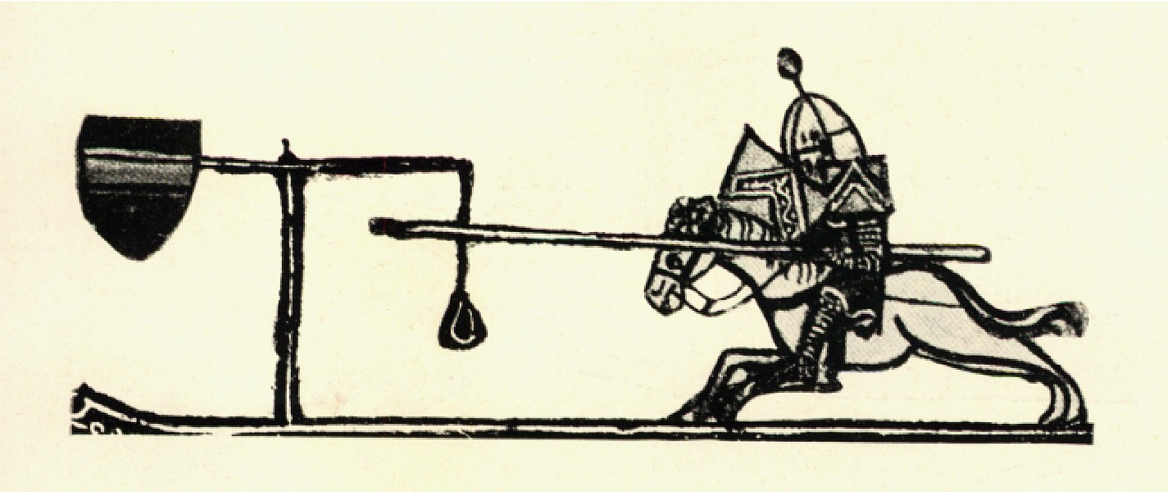
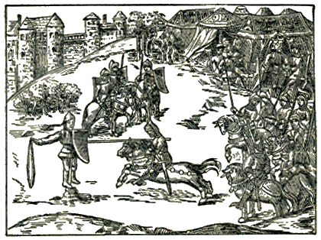
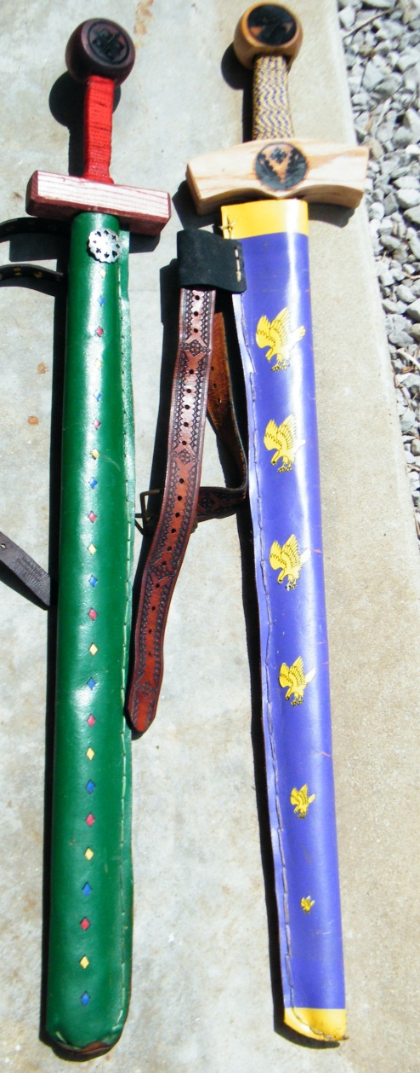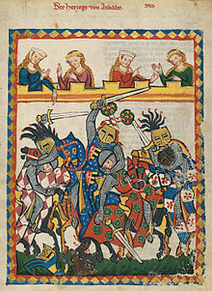
Wooden Tourney Swords and scabbards seen above – Bated metal blades or Wood swords were often used in the tournaments and wooden tourney swords can be seen in King René's Tournament Book.
How ours were made -Our swords we cut from oak and are assembled using wood glue and wood pins. The are branded with our devices in the pommel on one side and the Calon cross on the other. And the fyrd badge on cross guard of one. The sword on rights hand guard is wrapped in a purple and gold Kumihimo woven by Ise. The leather scabbards are painted and dyed using leather dye and acrylics paint. The falcons are a paper applique.

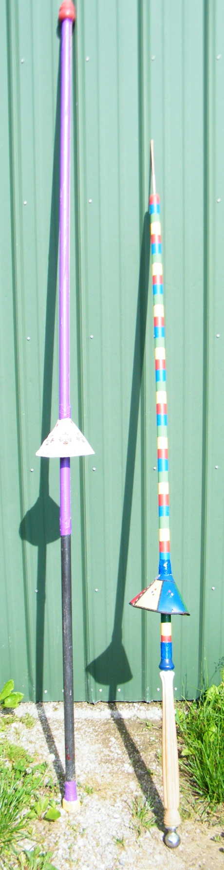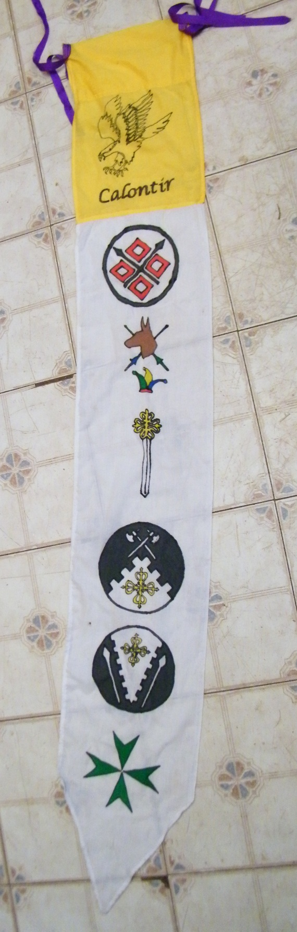

15th century Tourney Lances and Pennon seen above
Description of a Jousting Lance in period- The lance was the horseman’s spear. A long, strong, spear-like weapon, designed for use on horseback. History saw the spear develop into the Medieval Jousting Lance used during warfare during the Medieval times of the Middle Ages and was also a popular weapon used during jousting tournaments
- . It consisted of four parts – Truncheaon(shaft), the head, the vamplate, and Grate/Grapper.
- The Jousting Lance was made of wood, usually ash, and later of cypress, aspen and even pine, with a metal tip made of iron or steel similar to a spear head
- Knights would paint their Jousting Lance to match the colors of their livery or coats of arms
- The weapon measured from 9 to 14 feet in length
- Later a piece of armor called a vamplate which was a round of iron on the shaft of the weapon which was designed to protect the hand and arm. It first appeared as a small protective disk but grew to a conical shape by the 14th century. The vamplate was seldom used in warfare.
- A Grapper or rear plate was added to absorb the shock of jousting.
How and why I made the two lances and banner above
Purple lance on left- This is my attempt at a Tournament quintain striking lance. My vamplate is branded and tooled and then dyed/painted leather using inner ring of wire to keep its shape.
Jester colored lance above on Right -This is my attempt at a Tournament lance. The style of lance I made is a ring lance with vamplate to protect hand. My vamplate is tooled and dyed/painted leather using inner ring of wire to keep its shape. I included the vamplate to catch rings and keep them off my wrist and tangling my hand. I varied from the full metal design since this was to be a ring lance instead of a tilt lance to save weight. Shaft of my lance is pine rod stock tapered at the point. I socketed the rod stock into an old table leg I cored out as the handle. I cored and socketed the other end to fit a trailer hitch as a counter weight to balance the lance and take the weight off the front end. I choose not to add a Grapper since this is a ring lance.

Sources for my lance Info –
Joust and Tournaments Elizabethan Sports by Gretchen Elaine Maxwell and Alan Ryan Carey, A glossary of the Construction, decoration, and use of arms and armor By George Cameron Stone Page 407

Pennon above for Ring Lance –15th century war banner via silk resist dyeing. I made the above banner using modern Gutta resist and modern heat set silk dye. Designed to be a showing of my Kingdom, my heraldry, my awards and my orders.
How it was done in period –

History of Resist dyeing- (resist-dyeing) is a term for a number of traditional methods of dyeing textiles with patterns. Methods are used to "resist" or prevent the dye from reaching all the cloth, thereby creating a pattern and ground. The most common forms use wax, some type of paste, or a mechanical resist that manipulates the cloth such as tying or stitching. Resist dyeing was used in many countries including Japan, Africa, China and India and can be traced back as far as 500AD in China the jia xie method for dyeing (usually silk). (Reference Shelagh Vainker in Anne Farrer (ed), "Caves of the Thousand Buddhas" , 1990, British Museum publications, ISBN 0-7141-1447-2)
Coloring-
Pigments-The first colors used by humans were pigments and ochres. Pigments are colors in a powdered form that are mixed with a medium (like oil or egg) to make paint. Pigments were used to color cloth throughout history, but they do not make a permanent chemical bond with the fibers and may easily chip off.
Ochres - are mixtures of quartz sand, clay, and iron oxide in colors that range from brown and yellow through greens, reds, and violets. As paints they keep their bright colors, but on fiber the iron oxide mellows to red or tan.
Dyes- Most dyes are organic; derived from plants or animals. There are references to dyeing 1st C. AD, Roman Empire: Pliny the Elder. Natural History. Various reprints available. Refers to Egyptians as advanced dyers, with knowledge of mordanting and other dyeing secrets. And mentioned in period in 1400's Italy: Trattato dell' Arte della Lana. Reprinted of original Italian in Doren, Alfred. Die Florentiner Wollentuchindustrie. Stuttgart: J.G. Cotta'sche Buchhandlung Nachfolger, 1901.
Reference - Natural Dyeing to 1600-Anne Liese's Fibers and Stuff
History of Banners
People have used War Banners for over 4,000 years. Authentic flag design of ancient peoples includes a metal flag from Iran, ca. 3000 BC, and reconstructions of vexilloids shown on ancient Greek coins, Egyptian tomb carvings, etc.
The first type of flag was called a vexilloid. First flags or vexilloids were metal or wooden poles with carvings on top. About 2,000 years ago, pieces of fabric or material were added to some vexilloids for decoration. These looked more like the flags we know today.
In period and before People use banners to give others information, such as, who they are. Knights carried banners into battle because it was hard to know who the knights were when they were dressed up and covered in armor ready for battle! Banners were important because they helped soldiers tell their friends from their enemies in battle.
Reference - William G. Crampton; The World of Flags; Rand McNally; ISBN 0-528-83720-6 (hardcover, 1994)

Example of period banners

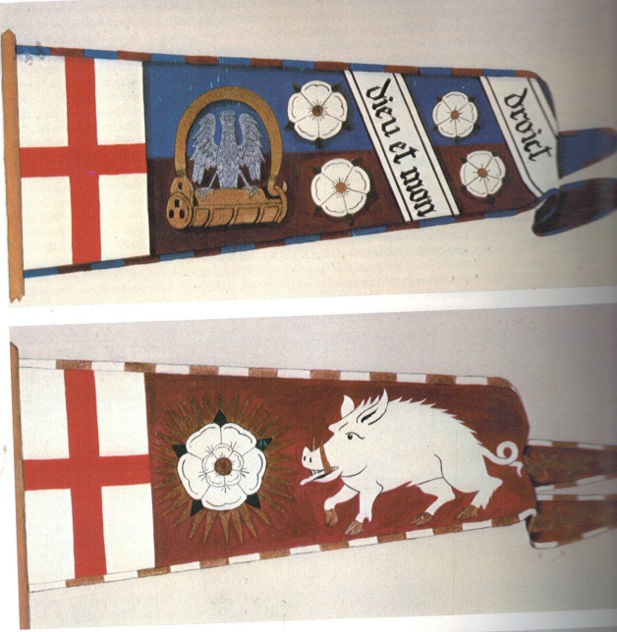

Banner of Edwards duke of York(Edwards the IV) and bottom is Richard the III both from the 1400’s. – Reference and photos from The Book of the Medieval Knight- Stephen Turnbull
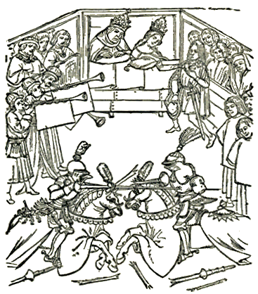

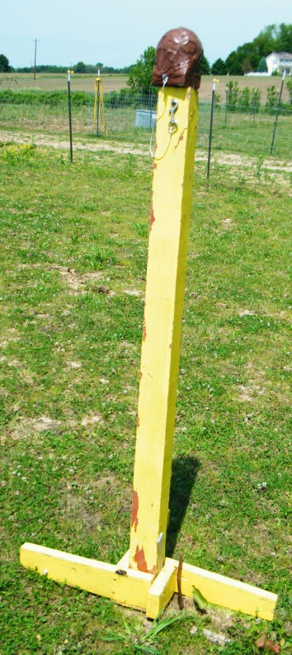
Reed and Head Stands seen above
Head and Reed stand above - We built 8 of the above wooden stands and 8 of a more modern style not pictured here. These stands are used to teach the mule and rider the skills of weaving and running a charge while the rider is swinging a sword. Reeds is based on a Turkish training exercise. Posts are placed in two rows, and topped by reeds/sticks of varying heights. The rider goes down the middle, and uses a sword to cut down each reed, alternating strikes to the left and right. An alternate version uses different post heights, starting at 5 feet, and then being reduced in size to 1 foot — the varying heights of the reeds would train a rider to hit multiple live targets at nearly any height, thereby hamstringing, beheading or disemboweling them.
H. Rabie, in “The Training of the Mamluk Faris”, writes: “At first, a green reed the height of the faris was fixed in the ground. The horseman approached it from the right, riding very fast, and cut a span from it. He repeated the exercise a number of times until only one dhira (about 26 inches) was left from the length of the reed. The next exercise consisted of fixing five reeds to the ground on the right hand side of the faris, the distance between each reed being ten dhira (about 21.3 feet). The faris approached on horseback, cutting each reed, piece by piece, as in the preceding exercise. The last exercise of this kind involved the placing of five reeds on the right hand and five more on the left hand for the faris to cut through, piece by piece.”

