15th century Tourney Lance with War banner by Sir Saito Jiro no Bitchu
Intermediate Tri- Level entry

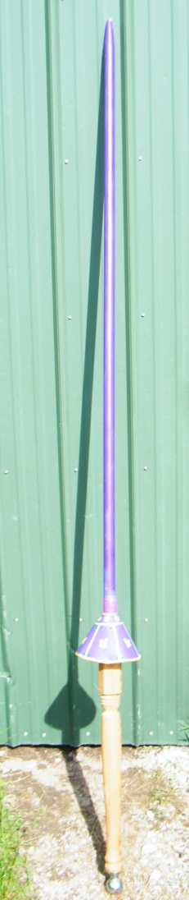
15th century Tourney Lance in history
Description of a Jousting Lance in period- The lance was the horseman’s spear. A long, strong, spear-like weapon, designed for use on horseback. History saw the spear develop into the Medieval Jousting Lance used during warfare during the Medieval times of the Middle Ages and was also a popular weapon used during jousting tournaments
- . It consisted of four parts – Truncheaon(shaft), the head, the vamplate, and Grate/Grapper.
- The Jousting Lance was made of wood, usually ash, and later of cypress, aspen and even pine, with a metal tip made of iron or steel similar to a spear head
- Knights would paint their Jousting Lance to match the colors of their livery or coats of arms
- The weapon measured from 9 to 14 feet in length
- Later a piece of armor called a vamplate which was a round of iron on the shaft of the weapon which was designed to protect the hand and arm. It first appeared as a small protective disk but grew to a conical shape by the 14th century. The vamplate was seldom used in warfare.
- A Grapper or rear plate was added to absorb the shock of jousting.
How and why I made my lance
This is my attempt at a Tournament lance. The style of lance I made is a ring lance with vamplate to protect hand. My vamplate is tooled and dyed/painted leather using inner ring of wire to keep its shape. I included the vamplate to catch rings and keep them off my wrist and tangling my hand. I varied from the full metal design since this was to be a ring lance instead of a tilt lance to save weight. Shaft of my lance is pine rod stock tapered at the point. I socketed the rod stock into an old table leg I cored out as the handle. I cored and socketed the other end to fit a trailer hitch as a counter weight to balance the lance and take the weight off the front end. I choose not to add a Grapper since this is a ring lance.
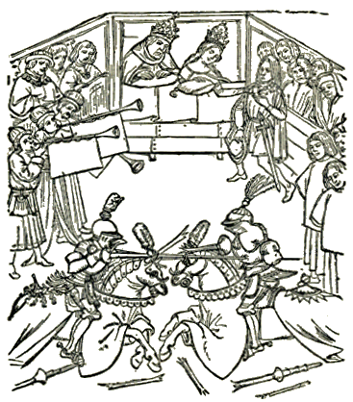
Sources for my lance Info –
Joust and Tournaments Elizabethan Sports by Gretchen Elaine Maxwell and Alan Ryan Carey

A glossary of the Construction, decoration, and use of arms and armor By George Cameron Stone Page 407

15th century war banner via silk resist dyeing
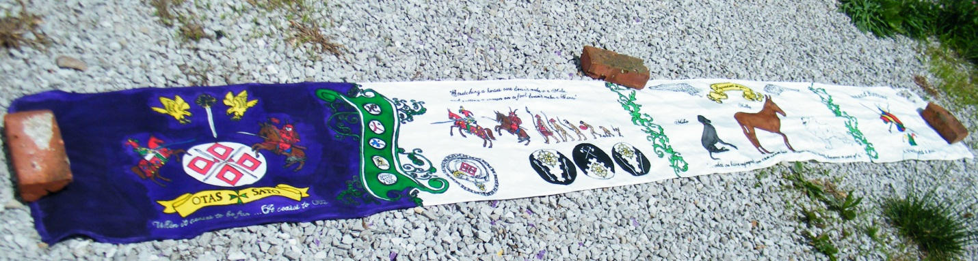
History of Resist dyeing
Resist dyeing (resist-dyeing) is a term for a number of traditional methods of dyeing textiles with patterns. Methods are used to "resist" or prevent the dye from reaching all the cloth, thereby creating a pattern and ground. The most common forms use wax, some type of paste, or a mechanical resist that manipulates the cloth such as tying or stitching. Resist dyeing was used in many countries including Japan, Africa, China and India and can be traced back as far as 500AD in China the jia xie method for dyeing (usually silk). (Reference Shelagh Vainker in Anne Farrer (ed), "Caves of the Thousand Buddhas" , 1990, British Museum publications, ISBN 0-7141-1447-2)

How it was done in period –
Coloring-
Pigments-The first colors used by humans were pigments and ochres. Pigments are colors in a powdered form that are mixed with a medium (like oil or egg) to make paint. Pigments were used to color cloth throughout history, but they do not make a permanent chemical bond with the fibers and may easily chip off.
Ochres - are mixtures of quartz sand, clay, and iron oxide in colors that range from brown and yellow through greens, reds, and violets. As paints they keep their bright colors, but on fiber the iron oxide mellows to red or tan.
Dyes- Most dyes are organic; derived from plants or animals. There are references to dyeing 1st C. AD, Roman Empire: Pliny the Elder. Natural History. Various reprints available. Refers to Egyptians as advanced dyers, with knowledge of mordanting and other dyeing secrets. And mentioned in period in 1400's Italy: Trattato dell' Arte della Lana. Reprinted of original Italian in Doren, Alfred. Die Florentiner Wollentuchindustrie. Stuttgart: J.G. Cotta'sche Buchhandlung Nachfolger, 1901.
Reference - Natural Dyeing to 1600-Anne Liese's Fibers and Stuff
History of Banners
People have used War Banners for over 4,000 years. Authentic flag design of ancient peoples includes a metal flag from Iran, ca. 3000 BC, and reconstructions of vexilloids shown on ancient Greek coins, Egyptian tomb carvings, etc.
The first type of flag was called a vexilloid. First flags or vexilloids were metal or wooden poles with carvings on top. About 2,000 years ago, pieces of fabric or material were added to some vexilloids for decoration. These looked more like the flags we know today.
In period and before People use banners to give others information, such as, who they are. Knights carried banners into battle because it was hard to know who the knights were when they were dressed up and covered in armor ready for battle! Banners were important because they helped soldiers tell their friends from their enemies in battle.
Reference - William G. Crampton; The World of Flags; Rand McNally; ISBN 0-528-83720-6 (hardcover, 1994)

Example of period banners including animals and text.

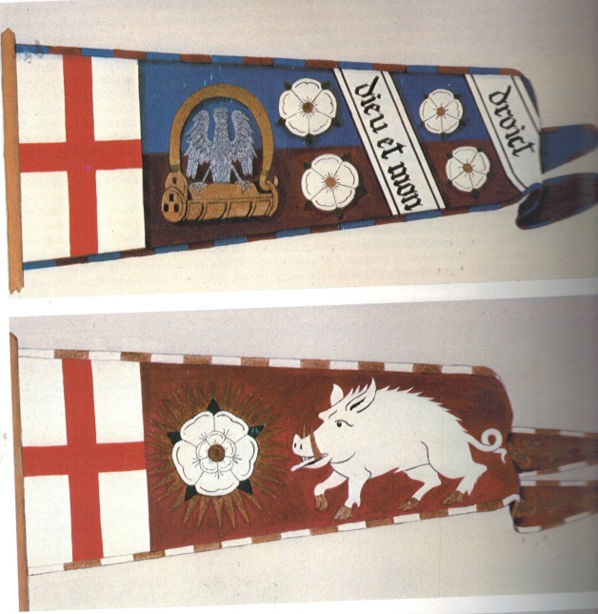

Banner of Edwards duke of York(Edwards the IV) and bottom is Richard the III both from the 1400’s. – Reference and photos from The Book of the Medieval Knight- Stephen Turnbull
How and Why I made my Banner
This 12ft long banner was the 6th silk resist banner I have tried. But it is far larger than any I have tried before and included a number of learning moments. I made this banner to be as long as possible but just long enough to not drag the ground from horse back using a lance to avoid the horse stepping on it. Measured this using scrap fabric from horseback. I made this banner using a stretching and resist then dye method. I built a special 13ft rack to stretch a piece of fabric this big and to allow for ease of applying resist and later dyeing over the 100 plus hours it took. 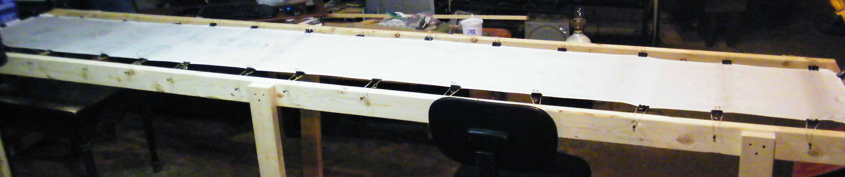
I started by penciling in all my artwork. I then stretched the fabric on the stretcher.
Next I applied the resist -Instead of Wax or rice paste for my resist I used a modern resist called Gutta. This I applied to all lines of the art and was a barrier to keep dye from spreading to other areas.
Next was Dyeing the silk- instead of berries or mold I used a modern heat set Silk dye applied by eye dropper. I had a small problem dyeing the first section purple when I had an inferior eye dropper leak. This combined with the large area I needed to dye with smaller areas that couldn’t be dyed caused an inconsistent purple color. This could nto be corrected without the color going from purple to black so I chose to leave it as is. In future banners I will look for a better application method for larger areas. My current methods work fine for small to medium areas.

Why I chose the art I did
The banner was designed to be carried by and an expression of my Samurai persona and my Jester persona.
The first section is my heraldry with a samurai and jester mounted to each side and my persona names to each side. My house moto is at the bottom “When it ceases to be fun it ceases to be” And a green Order of St. Lazarus cross is present to represent my crusader persona. Falcons and a sword of Calontir to show I am Calontir.
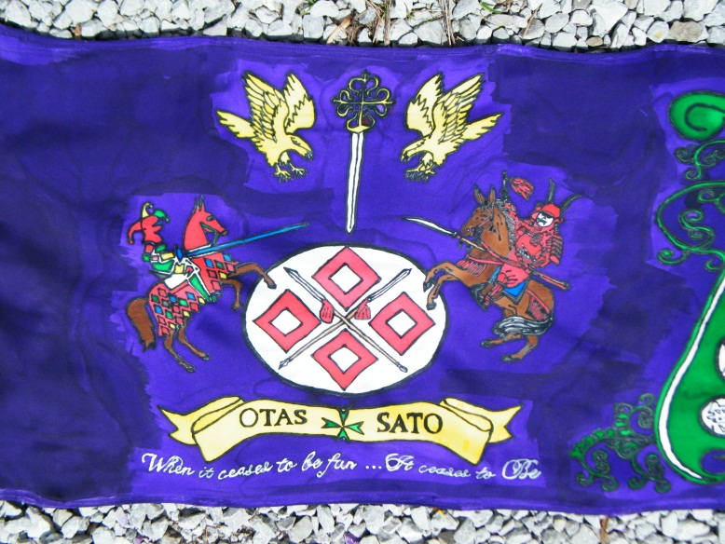
The next section has the 5 rings from The Book of Five Rings (Go Rin No Sho) by Miyamoto Musashi (c. 1584 – June 13, 1645), a book on strategy, tactics, and philosophy that is still studied today. Miyamoto Musashi is widely considered as one of the greatest warriors of all time. This book has inspired me over the years. To its right is my device in a chain and belt and Marshal awards of Calontior I have earned. Above the awards is my rendition of a cross between Darwin’s progressions of man done in The Bayeux Tapestry like style. Above that is a Jesters commentary on mules and leadership. It is always a Jesters place to say the unsaid and be heard but ignored since they are but a fool. 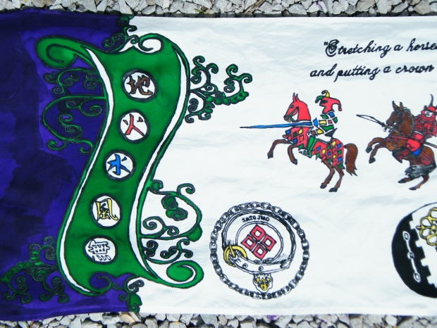 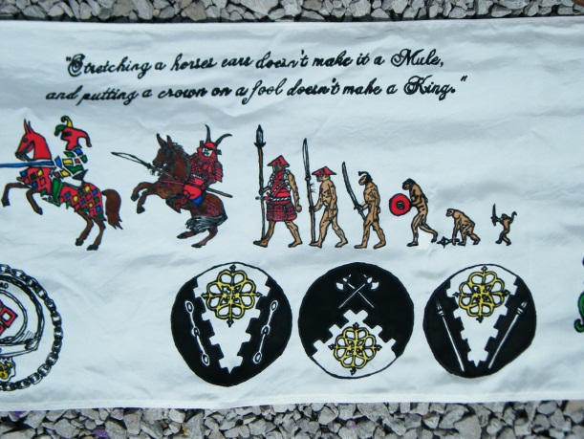

The next section is dedicated to fallen comrades. Rest in peace across the top and Depictions of my Great Dane named Miko, my Great Pryness named Osa and my Mule named Molly. The text across the bottom reads “What we have enjoyed we can never lose….all that we love deeply becomes a part of us” The three of them traveled to many SCA events and wars with me over the 10+ years they were with me and are greatly missed by myself and many other SCA. It seems appropriate for a war banner to remember fallen comrades
. 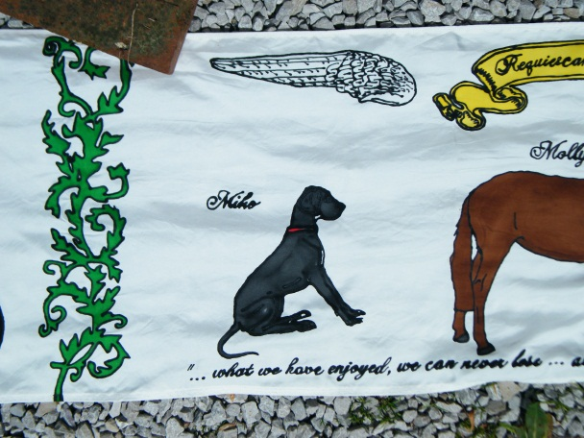 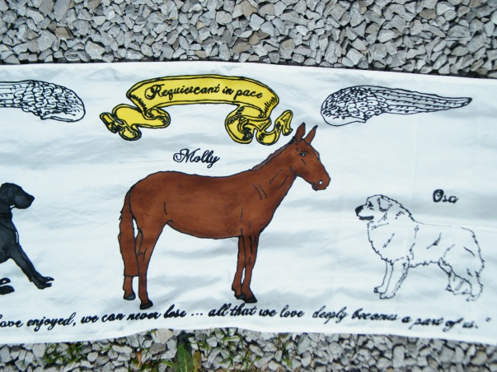

The last section is my alternate device I have used for years as my Jester named Otas. 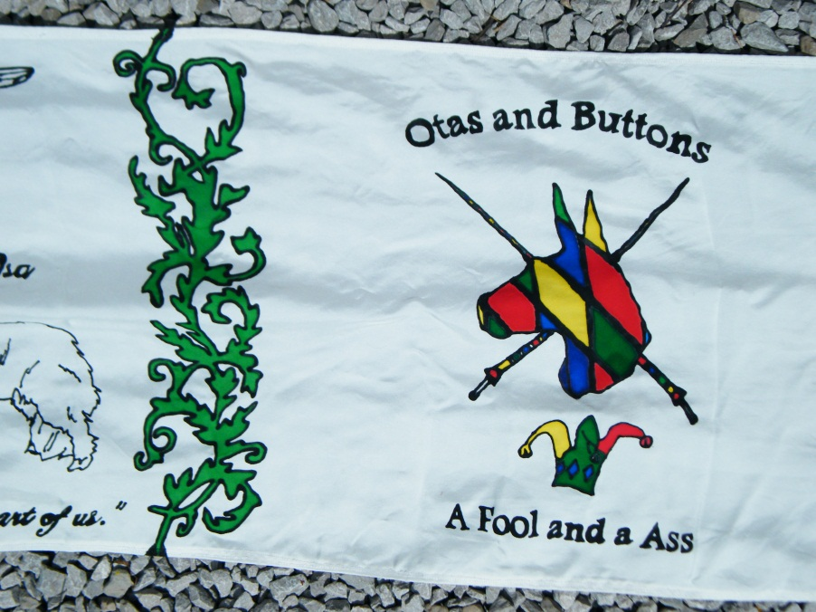

This banner was made with thoughts to being period but at the same time it was made for me with my sense of humor and style and cherished things and ideals some of which are inspired form non period sources.

